Additional Questions

Virtual Dissection 1-Vertebral Column, Spinal Cord, Back
Name the major ligaments that stabilize the lumbar spine, from anterior to posterior. To see the answer below, right click on the black box --> order --> send to back:
Anterior longitudinal, posterior longitudinal, ligamentum flavum, interspinous, supraspinous

Question for Virtual Dissection 2 - Gluteal Region, Thigh, Knee
Name the 2 major ligaments within the knee, their attachment site on the tibia and the motion that they resist. To see the answer below, right click on the black box --> order --> send to back:
Anterior cruciate: attaches to anterior tibia, resists anterior displacement of the tibia with respect to the femur. Posterior cruciate: attaches to posterior tibia, resists posterior displacement of the tibia with respect to the femur.

Question for Virtual Dissection 3 – Leg, Ankle, Foot
Draw and label the tendons crossing the ankle joint . To see the answer below, move the black box to the right:
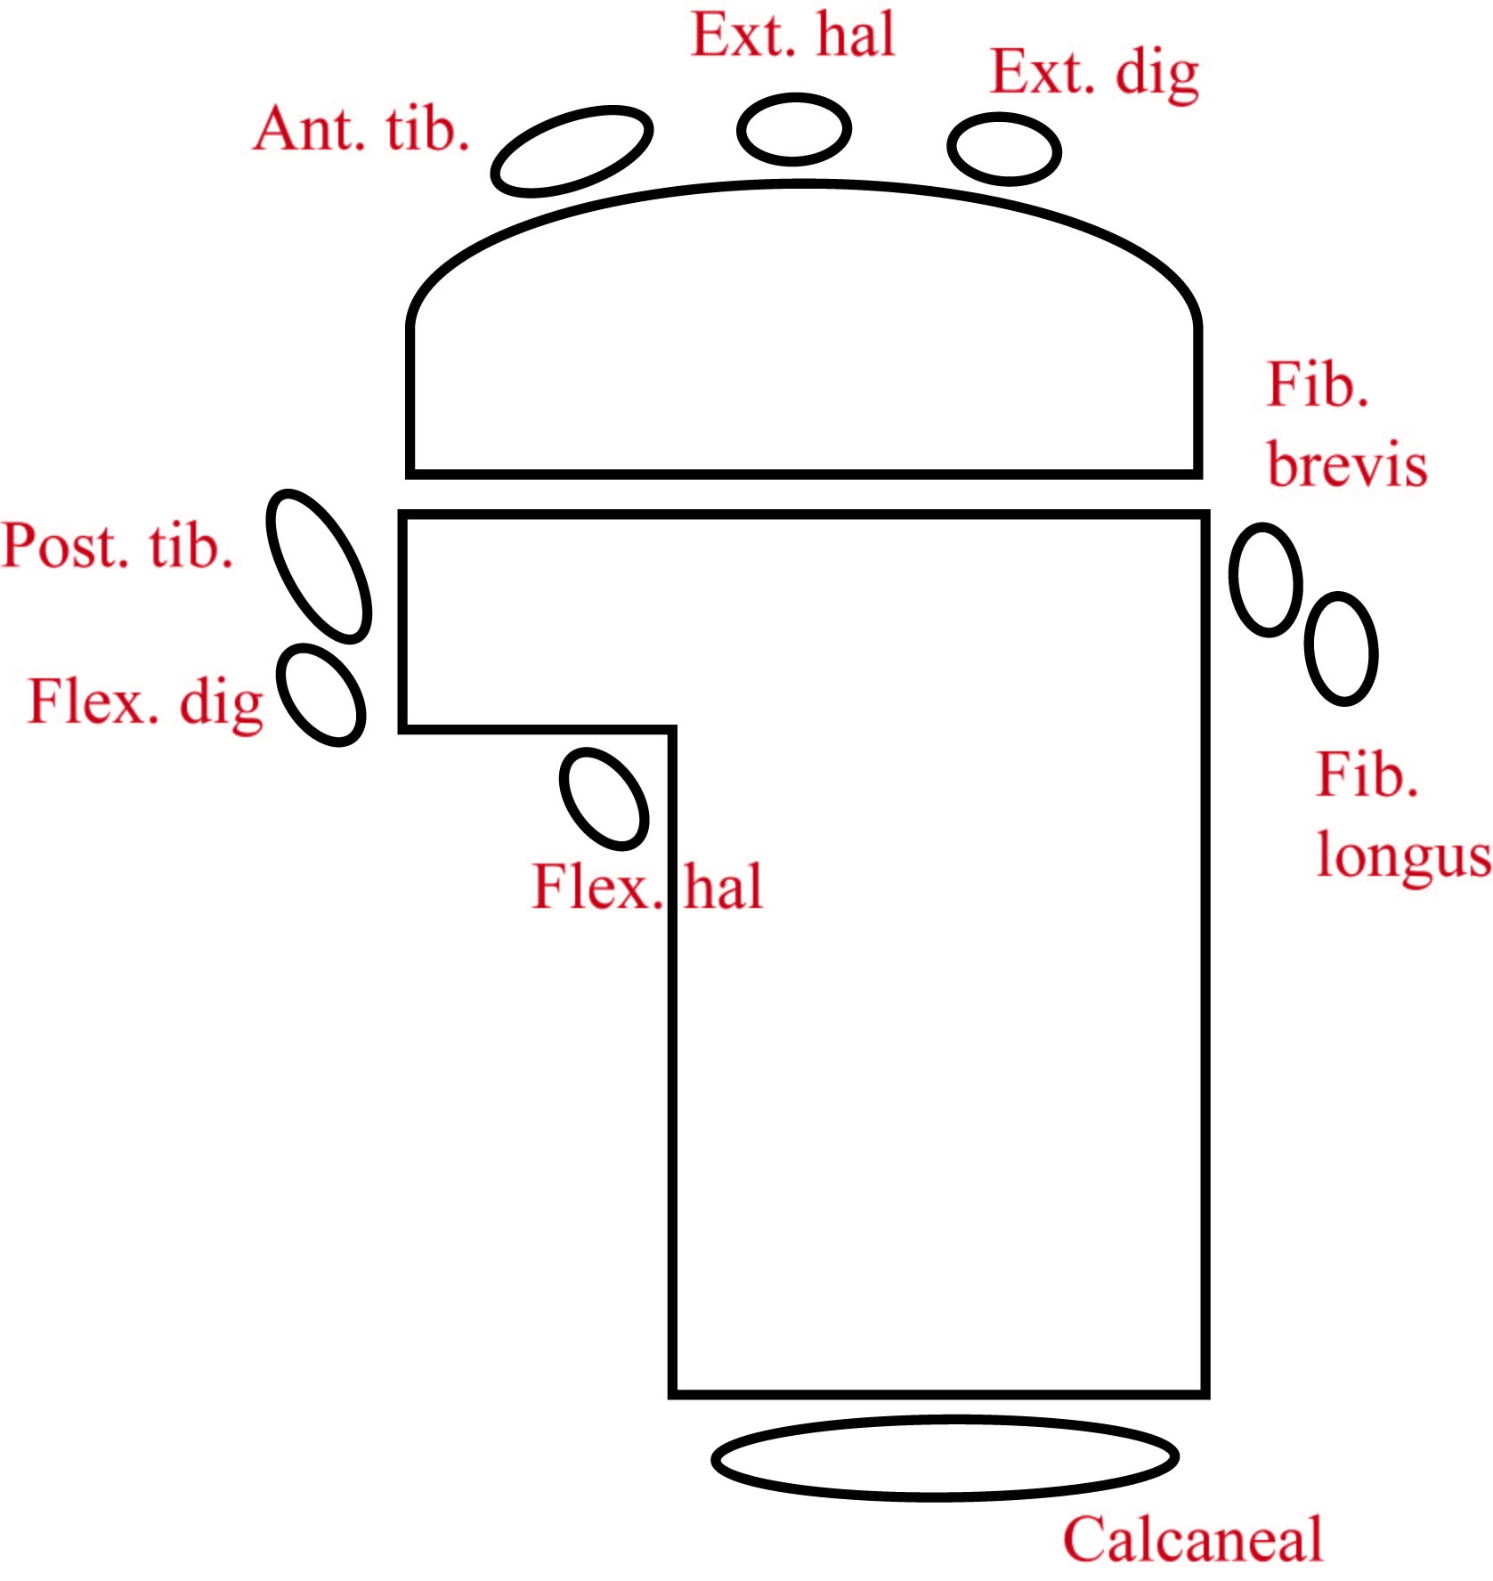

Question for Virtual Dissection 4 – Neck
Name the three vessels that arise from the aortic arch, from right to left. To see the answer below, right click on the black box --> order --> send to back:
Brachiocephalic, left common carotid, left subclavian

Question for Virtual Dissection 5 – Shoulder, Axilla, Arm
Name the four rotator cuff muscles and the part of the humerus onto which they insert. To see the answer below, right click on the black box --> order --> send to back:
Subscapularis is anterior to the scapula, inserts on lesser tuberosity. Supraspinatus, Infraspinatus and Teres minor arise from the posterior scapula, insert on greater tuberosity.

Question for Virtual Dissection 6 – Elbow, Forearm, Wrist, Hand
Palpate your medial epicondyle. Name the nerve just posterior to the medial epicondyle, the ligament that inserts on the medial epicondyle and the muscles that arise from the medial epicondyle. To see the answer below, right click on the black box --> order --> send to back:

Remember when you palpate, your arm should be in the anatomical position, i.e. the side of your arm with the little finger is medial. The Ulnar nerve runs behind the medial epicondyle, the muscles that arise from the medial epicondyle are the pronator teres, the palmaris longus and three flexors that arise from a common flexor tendon: the Flexor carpi radialis, flexor carpi ulnaris and the flexor digitorum superficialis.

Question for Virtual Dissection 7 - Thoracic Wall, Pleura, Lungs
What is the name of the congenital narrowing of the aorta that occurs just distal to the origin of the left Subclavian artery? Pretend that you are a drop of blood in the aortic arch, how would you bypass this narrowing to reach the lower extremities? To see the answer below, right click on the black box --> order --> send to back:

This condition is called coarctation. Blood flow: Aortic arch-->Subclavian artery-->Internal thoracic artery-->Anterior intercostal artery-->Posterior intercostal artery-->Descending thoracic aorta

Question for Virtual Dissection 8 – Face, Cranium, Cranial Contents
Name the components of the Circle of Willis from posterior to anterior. To see the answer below, right click on the black box --> order --> send to back:
Posterior cerebral artery-->Posterior communicating artery-->Internal carotid artery (gives rise to Middle and anterior cerebral arteries)-->Anterior cerebral artery-->Anterior communicating artery

Question for Virtual Dissection 9 – Eye, Bony Orbit, Orbital Contents
Name the six extraocular muscles and their innervation. To see the answer below, right click on the black box --> order --> send to back:

Superior/ inferior/medial rectus and inferior oblique muscles innervated by the Oculomotor nerve. Lateral rectus innervated by the Abducens nerve and Superior oblique innervated by the Trochlear nerve.

Question for Virtual Dissection 10 – Heart, Mediastinum (Superior, Inferior [ant, mid, post])
Trace the flow of blood from the SVC into the aorta. To see the answer below, right click on the black box --> order --> send to back:
SVC-->Right atrium-->Tricuspid valve-->Right ventricle-->Pulmonic valve-->Pulmonary artery-->Lung-->Pulmonic vein-->Left atrium-->Mitral valve-->Left ventricle-->Aortic valve-->Ascending aorta

Question for Virtual Dissection 11 - Pharynx, Larynx, Ear
Name the laryngeal cartilages involved in airway protection and voice production. Name the laryngeal muscles involved in airway protection and voice production and, based on your knowledge of the laryngeal cartilages and the fact that most of the laryngeal muscles are named for their origin/insertion on the laryngeal muscles, try to imagine the course of these muscles. Finally name the major function of each laryngeal muscle. To see the answer below, right click on the black box --> order --> send to back:
Cartilages: Epiglottis, Cricoid and Thyroid, all unpaired. Paired Arytenoids. Muscles and functions: cricothyroid and vocalis-->tighten the vocal cords increase pitch, oblique/transverse arytenoids, lateral cricoarytenoid-->adduct the cords, prevent aspiration, thyroarytenoids-->loosen the cords, decrease pitch, posterior cricoarytenoid --> abduct the cords, breath. All muscles innervated by recurrent laryngeal nerve except the cricoythyroid.

Question for Virtual Dissection 12 – Nasal, Oral, Infratemporal Fossa, Pterygopalatine Fossa
Name the paranasal sinuses and the meatus or recess into which the sinus drains. To see the answer below, right click on the black box --> order --> send to back:
Frontal sinus-->middle meatus, anterior and middle ethmoid air cells-->middle meatus, posterior ethmoid air cells -->superior meatus, sphenoid sinus-->sphenoethmoid recess, maxillary sinus-->middle meatus

Question for Virtual Dissection 13 - Abdominal Wall, Inguinal Region, Peritoneum
Name the contents of the spermatic cord. To see the answer below, right click on the black box --> order --> send to back:

Spermatic cord contents: arteries (testicular, derential, cremasteric), nerves (sympathetic/parasympathetic fibers, genital branch of the genitofemoral nerve), veins (pampiniform plexus), lymphatics, ductus deferens, vestige of the processus vaginalis (tunica vaginalis)

Question for Virtual Dissection 14 –GI Organs, Kidney, Posterior Abdominal Wall, Diaphragm
What two structures are immediately anterior to the portal vein in the porta hepatis. To see the answer below, right click on the black box --> order --> send to back:
Proper hepatic artery and the common bile duct.

Question for Virtual Dissection 15 – Pelvis, Perineum
Name the muscles that form the principle landmarks of the pelvis. To see the answer below, right click on the black box --> order --> send to back:

Levator ani (puborectalis, pubococcygeus and iliococcygeus muscles), coccygeus, obturator internus and pirriformis

